**Lab 16**

* Section 1: Step 15 A screenshot of a computer

  Description automatically generated
* Section 2: Step 4 A screenshot of a computer

  Description automatically generated
* Section 3.1: Step 12 A screenshot of a computer

  Description automatically generated
* Section 3.4: Step 5 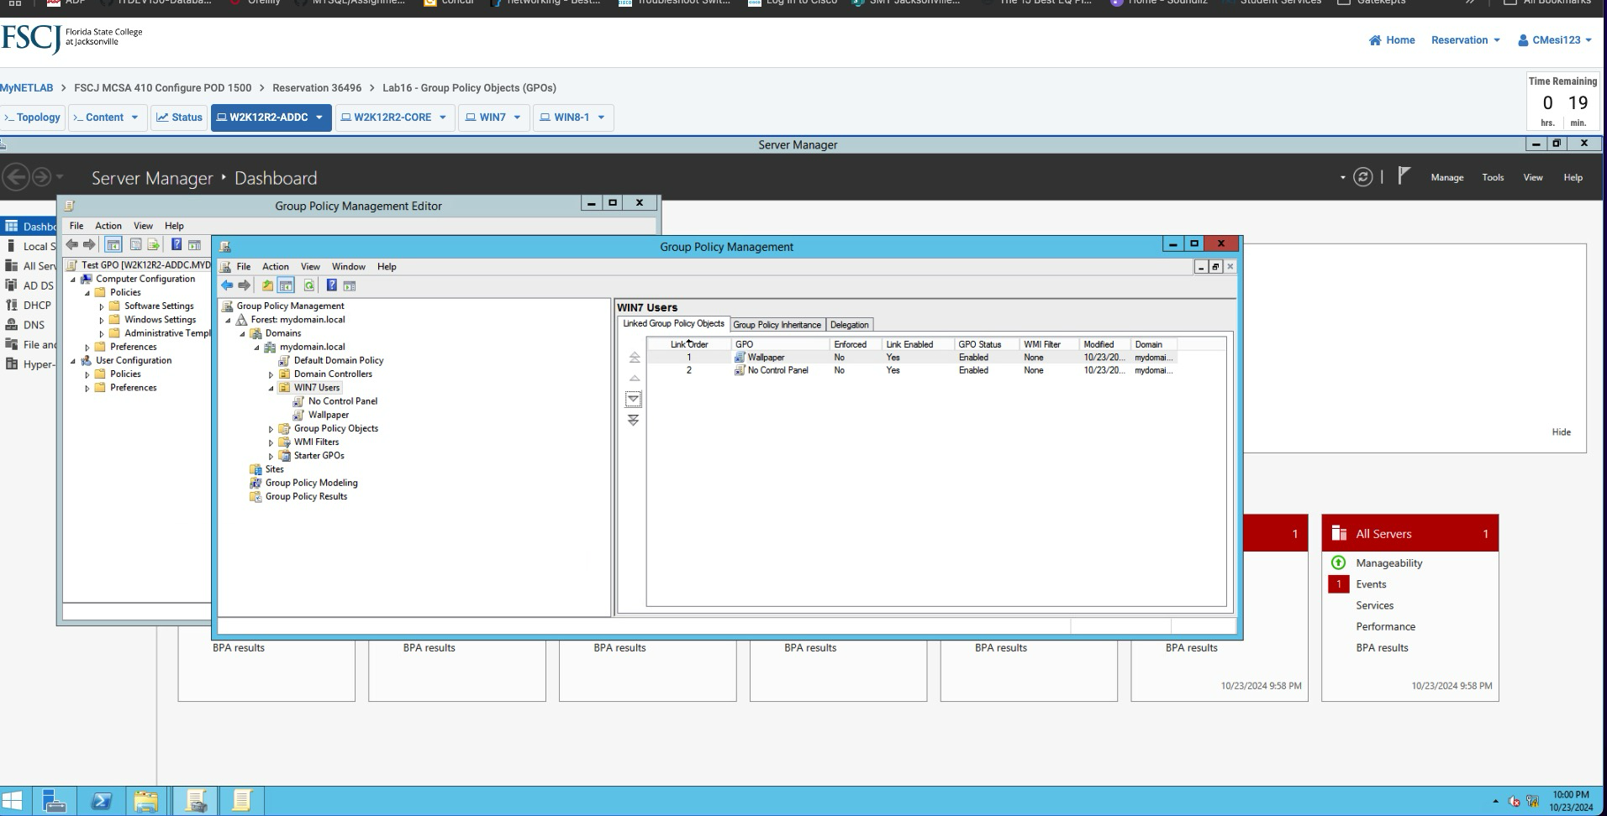

**Lab 17**

* Section 1.1: Step 28
* Section 2.1: Steps 15 and 16
* Section 3.1: Step 3
* Section 3.2: Step 11
* Section 3.3: Step 15